**LEBANESE AMERICAN UNIVERSITY**

**USAID – HIGHER EDUCATION SCHOLARSHIP PROGRAM**

**HES - Volunteering Program Verification Form**

This form is to be used to document volunteering hours. If a student volunteers for multiple organizations, a separate form must be used for each organization. **This form must be turned in by the 28th of each month, the latest.**

I certify that the scholar Nadine Al Hawwat completed a total of 1 hours of service at InnovaThrive.

The hours were completed hours as per the below:

Hours # 0 (date) _2/12 – 6/12_ (initials of supervisor) __A.K.___

Hours # 0 (date) _9/12 – 13/12_ (initials of supervisor) __A.K.___

Hours # 0 date) _16/12 – 20/12 (initials of supervisor) __A.K.___

Hours # 1 date) _23/12 - 27/12 (initials of supervisor) __A.K.___

Brief description of the activities the scholar performed or participated in:

Nadine Al Hawwat conducted research on the topic of "Blockchain’s Role in Supply Chain Transparency," focusing on both its advantages (Increased trust among stakeholders) and disadvantages(Implementation complexities and costs).

Written feedback about the scholar’s performance:

Nadine’s research on blockchain in supply chain transparency highlighted both the advantages, like increased trust, and the challenges, such as implementation complexities. It provided a well-rounded perspective on blockchain's potential in supply chain management

Please rate the overall performance of the scholar at your organization:

|  |  |  |  |
| --- | --- | --- | --- |
|  | Mastery (5) | Proficient (3) | Emerging (1) |
| **Problem solver** | X |  |  |
| **Engaged & Committed** | X |  |  |
| **Open-minded & multicultural** | X |  |  |

Signature

& stamp

__________________________

_

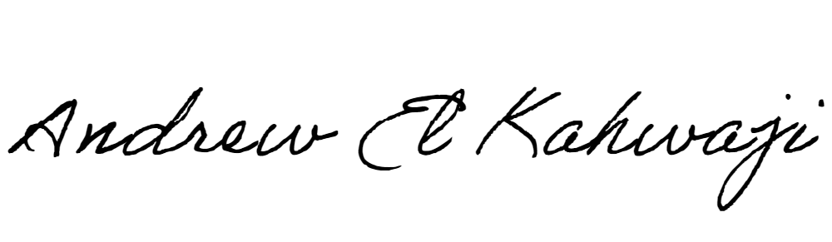

Printed Name _Andrew El Kahwaji_

Date __26/12/2024___

Email __andrew.lifesculptor.coo@gmail.com __

Phone __+961 71 914 378__